Lab 4: Proximity Analysis of Polling Places to Census Tracts with High Asian American Populations

Objective:
We will analyze polling place proximity to census tracts with high Asian American populations using QGIS. The steps involve loading census and polling location data, filtering for census tracts with high Asian American populations, and calculating distances between these tracts and polling places.

Part 1: Loading Data into QGIS (see prior labs and recording for guidance here)
- Open QGIS:
  - Launch QGIS on your system.
- Load Census Tract Data:
  - Go to Layer > Add Layer > Add Vector Layer.
  - In the dialog box, click Browse and select your census tract shapefile (.shp).
  - Click Open. The census tracts should now appear on the map.
- Load Polling Place Data:
  - If you have polling place addresses, you need to geocode them into latitude/longitude. If polling locations are already geocoded, load the shapefile.
  - In the dialog box, click Browse and select your census tract shapefile (.shp).
  - Click Open. The census tracts should now appear on the map.

Part 2: Filtering Dekalb and Fulton County Census Tracts by High Asian American Population
- Open the Census Tract Attribute Table:
  - Right-click on the census tracts layer in the Layers Panel.
  - Select Open Attribute Table.
- Identify the Asian American Population Column:
  - In the table, locate the column representing Asian American population (Asian_Pop or similar, depending on your dataset).
- Select Tracts with High Asian American Population:
  - In the attribute table, click the Select by Expression icon (top left).
  - In the Expression dialog, enter a query to filter tracts with a high Asian population. For example:
"Percent Asian of Census Tract" > 25

Click Select Features. Tracts meeting the criteria will be highlighted on the map.

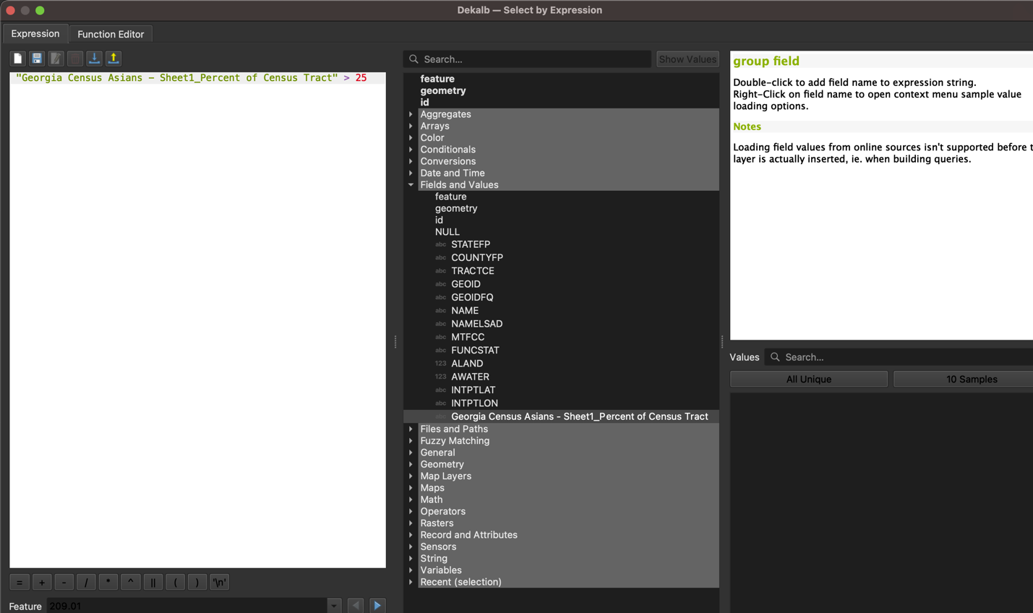
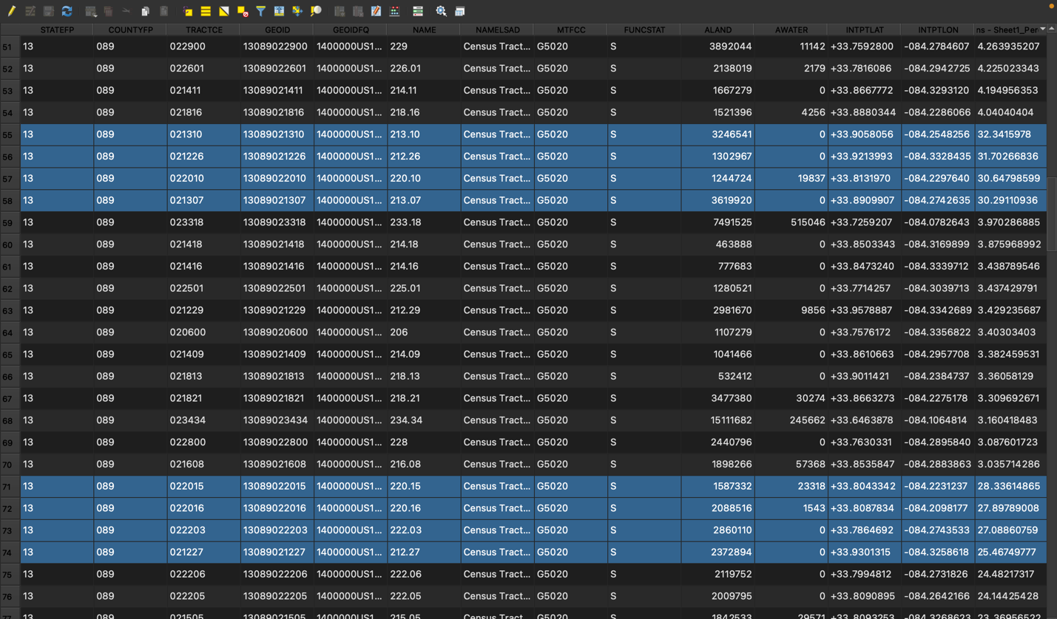

Create a New Layer with Selected Features:
- Right-click on the census tract layer again, choose Export > Save Selected Features As….
- Save this as a new shapefile (e.g., Dekalb_High_Asian_Population_Tracts.shp or Fulton_High_Asian_Population_Tracts.shp).
- Click OK to create the new layer with filtered tracts.

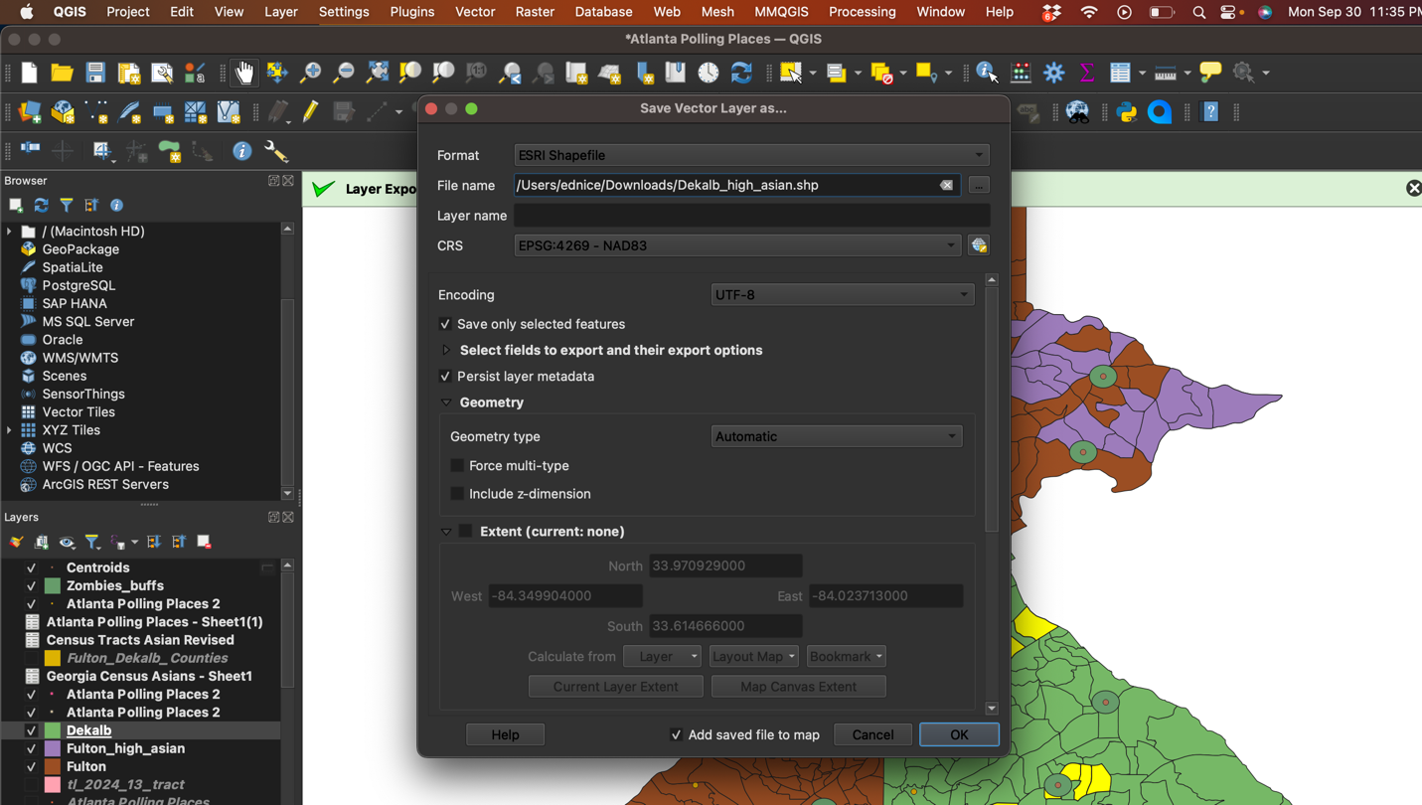

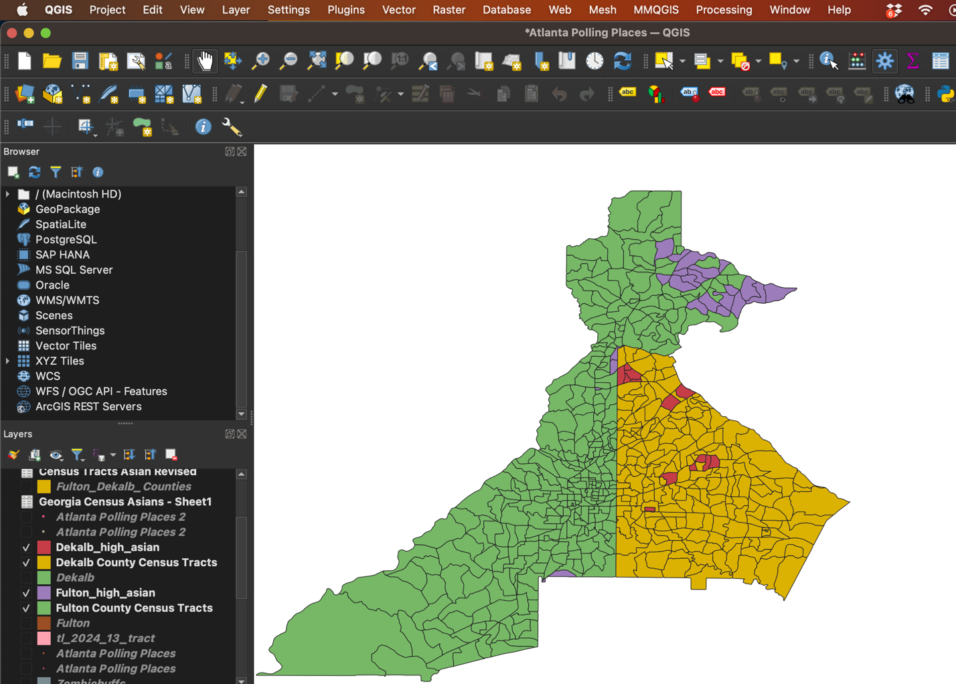

Part 3: Using Buffers to Define Polling Place Proximity (see Lab 3.1 also on Buffers)
In this section, you’ll create buffer zones around polling places to analyze which census tracts fall within a certain distance of polling locations.
Install MMQGIS Plugin (if not installed)
- Install the MMQGIS Plugin:
  - Go to Plugins > Manage and Install Plugins.
  - Search for MMQGIS in the search bar.
  - Select it and click Install Plugin.

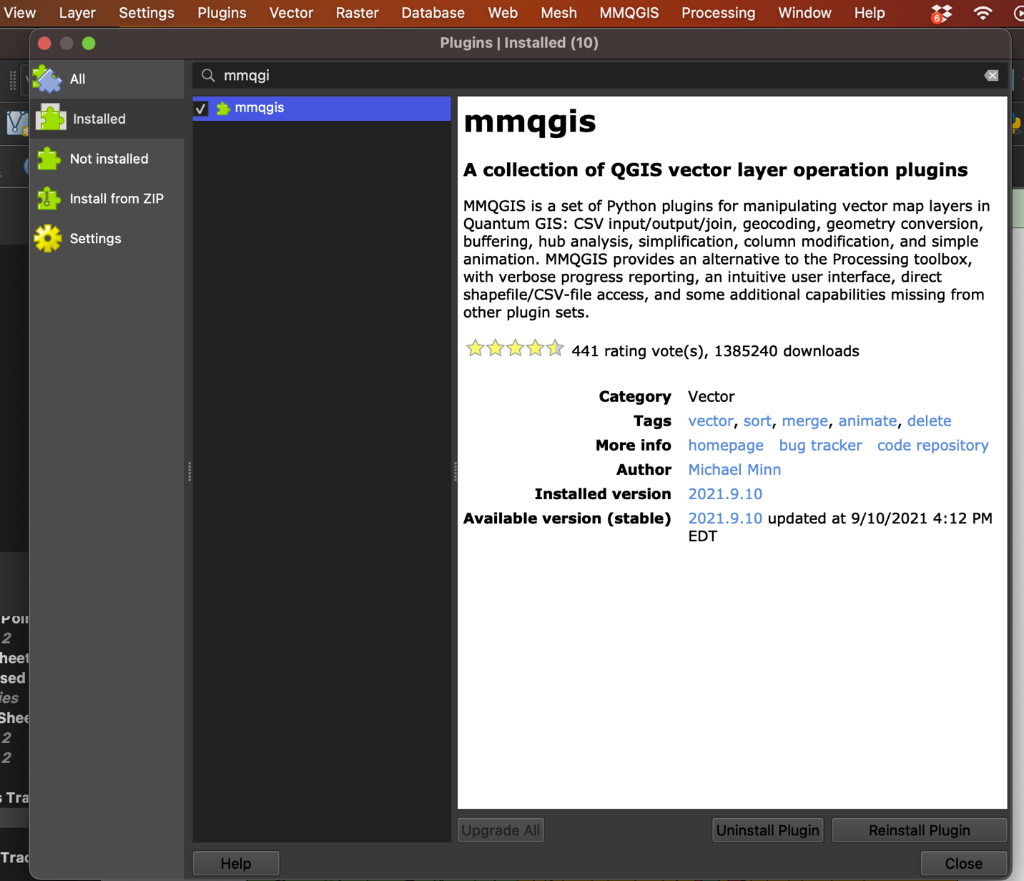
Create Buffers Around Polling Places
- Open the MMQGIS Buffer Tool:
  - Once the MMQGIS plugin is installed, go to MMQGIS in the top menu.
  - Select Create > Buffers.

- Configure the Buffer Tool:
  - In the Buffer Parameters dialog box:
    - Select the Polling Places layer as the Input Layer.
    - Choose the Buffer Distance (e.g., 500 meters or 0.5 mile).
    - Set the Output Layer path to save the buffer output (e.g., Polling_Place_Buffers.shp).

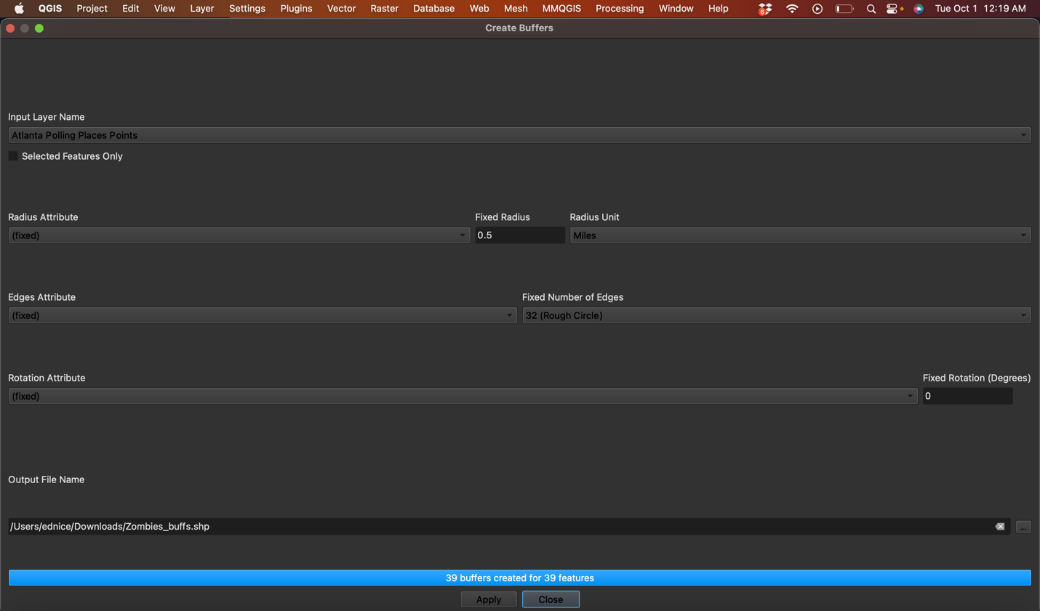

- Create Buffers:
  - Click OK. The buffer zones will appear around each polling place on the map.

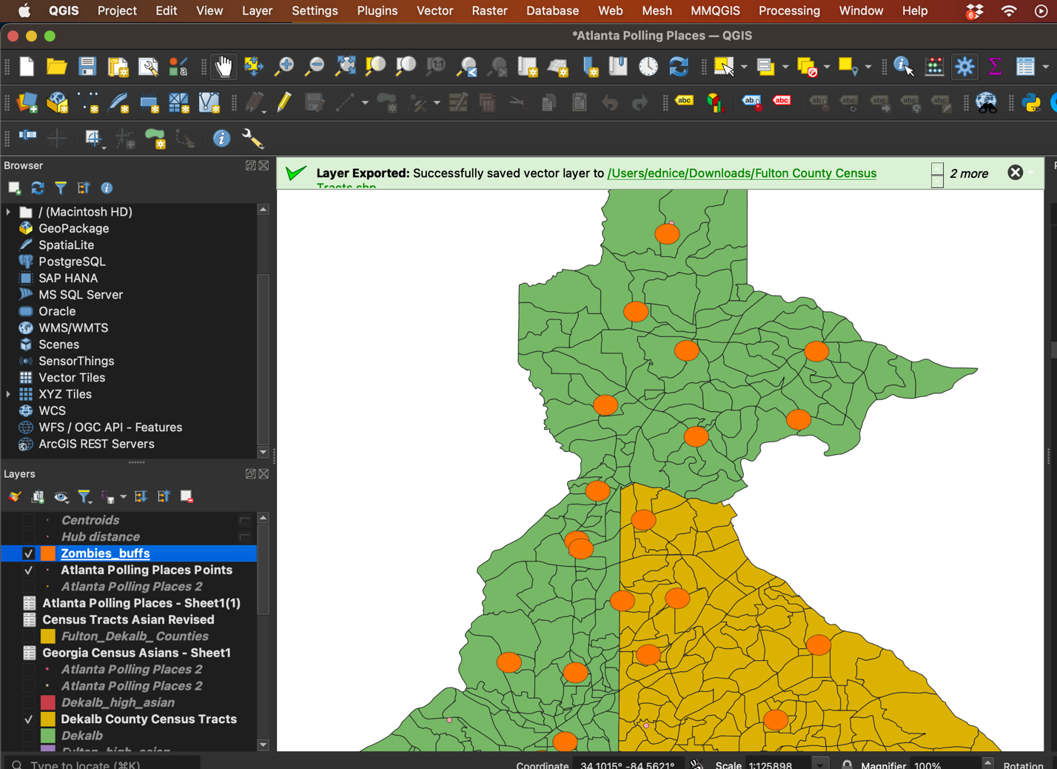

Part 4: Calculating Distance from Census Tracts to Polling Places
Method 1: Distance to Nearest Hub (miles)
- Activate the "Distance to Nearest Hub" Tool:
  - Go to the Processing Toolbox (right panel).
  - Search for and open the Distance to Nearest Hub tool.
- Configure the Tool:
  - In the Distance to Nearest Hub dialog:
    - Select your Dekalb_High_Asian_Population_Tracts and Fulton_High_Asian_Population_Tracts layer as the Input layer.
    - Select your Polling Places layer as the Hub layer.
    - Select miles as the distance.
    - Select one of the Census Tract names like GEOID to use as a match to the nearest polling location as the HubName.
    - Choose Output layer to save the results.
- Run the Analysis:
  - Click Run. The tool will compute the straight-line distance from the centroid of each census tract to the nearest polling place.
  - The output will be a new layer showing the nearest polling place and the distance for each tract.

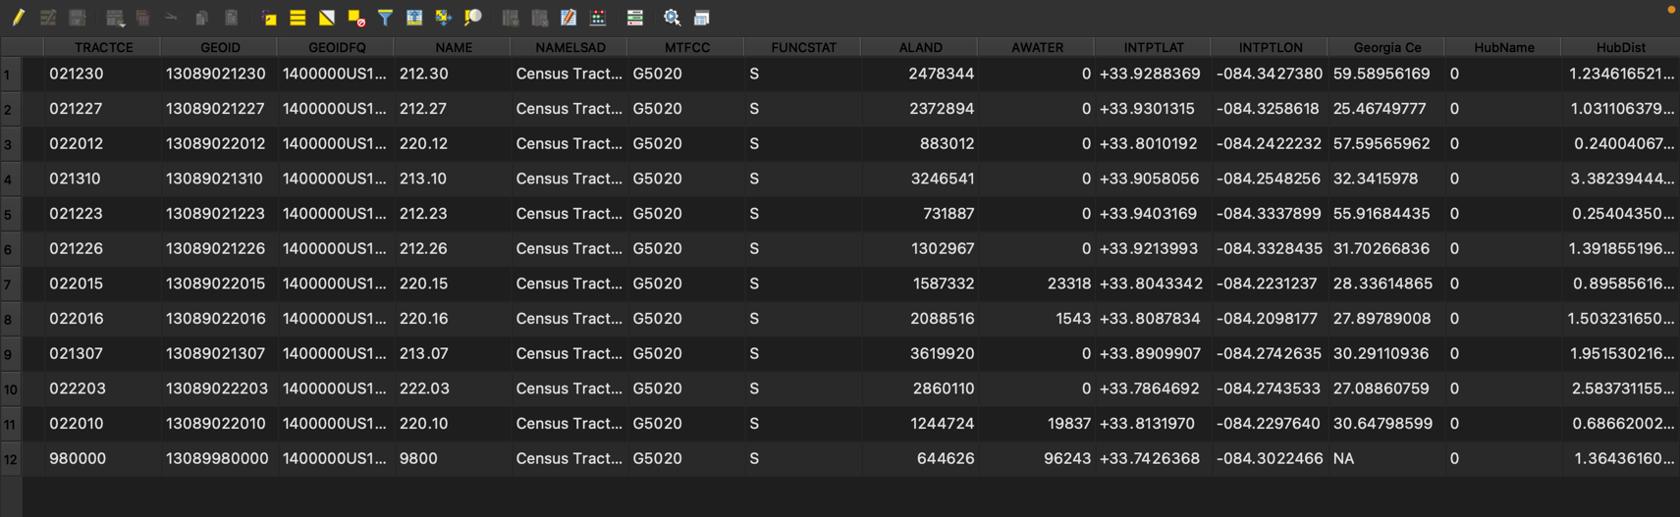

Part 5: Summarizing Coverage within Buffers
- Spatial Join (Optional):
  - To determine how many high Asian population tracts fall within the polling place buffers, perform a spatial join:
    - Go to Vector > Data Management Tools > Join attributes by location.
    - Set the high population census tracts layer as the target layer and the polling place buffers as the join layer.
    - Choose the “intersects” predicate and run the tool.
  - Open the resulting attribute table and use the Field Statistics tool on a new field (e.g., a binary indicator for whether a tract is covered) to calculate the percentage of tracts within the buffer distance.
- Interpreting the Data:
  - Summarize your findings in a short report noting how many tracts are within the desired proximity and discussing any outliers (tracts with especially high distances).

Part 6: Use the "Join Attributes by Location (Summary)" Tool (optional)
- Access the Tool:
• In QGIS, open the Processing Toolbox.
• Search for Join Attributes by Location (Summary).
- Configure Parameters:
• Input Layer: Set your high Asian population census tracts layer.
• Join Layer: Set your polling place buffers layer (or polling places if you prefer a direct join).
• Geometric Predicate: Select “intersect” so that any overlap between a tract and a buffer counts.
• Summaries to Calculate:
  - Count: This will add a field (e.g., “count”) that indicates how many polling places (or buffer overlaps) each tract has.
  - Optional Additional Statistics: If your polling place layer includes numeric attributes (like capacity or distance), you can calculate sums, means, or other statistics as needed.
- Run the Tool:
• Execute the tool to generate a new output layer that includes these summary statistics.

Part 6: Creating a Final Map Layout

A. Preparing Your Map Layers
- Symbology Adjustments:
  - High Population Tracts:
• Style these with a bold outline and a semi-transparent fill (e.g., a bright color like red or orange) so they stand out. You can print these alone and label as “high Asian tracts.”
  - Polling Places:
• Use distinct symbols (such as star or circle markers) in a contrasting color.
  - Buffer Zones:
• Style these with a subtle, semi-transparent fill (e.g., light blue) and a dashed border to indicate the area of influence.
- Layer Order:
  - Ensure that the buffer zones are layered below the polling place markers and that the high population tracts are visible and not obscured by other elements.

B. Setting Up the Print Layout
- Create a New Print Layout:
  - Go to Project > New Print Layout.
  - Give your layout a meaningful name (e.g., “High Asian Population Polling Proximity Map”).
- Add the Map:
  - Click the Add Map tool from the toolbar in the Print Layout window.
  - Draw a rectangle where you’d like your map to appear.
  - Adjust the extent by selecting the map frame and using the Item Properties panel to refine what is displayed.
- Add Map Elements:
  - Legend:
• Use the Add Legend tool to insert a legend that explains the symbology. Customize the legend items as needed.
  - Scale Bar:
• Add a scale bar by clicking the Add Scale Bar tool. Adjust its style and units (miles or kilometers) in the properties panel.
  - North Arrow:
• Insert a north arrow using the Add Picture tool. Select one from the available options.
  - Title and Text Boxes:
• Use the Add Label tool to insert a map title and any descriptive text (e.g., methodology, key findings). This text can explain the significance of high Asian population tracts and polling place proximity.
  - Additional Annotations:
• Optionally add a subtitle, data source acknowledgments, or contact information if needed.
- Final Adjustments:
  - Review the layout to ensure all elements are balanced and clearly visible.
  - Adjust font sizes, colors, and placement to enhance readability.
  - Check that your map is not overcrowded; keep the design clean and focused on the critical information.
- Export Your Map:
  - Once satisfied, export your layout by going to Layout > Export as PDF/Image.
  - Choose the appropriate resolution and file format based on your submission requirements.
  - Save Map to Courseworks as Lab 4

